Children’s Space, 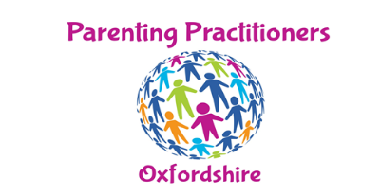

Introduction to the Service
NB. For brevity we refer to ‘parents’ as primary caregivers but please note we acknowledge that in some circumstances those who are not necessarily biological parents are primary caregivers.

As you work your way through mediation and/or separation you will, if you have children, have very natural concerns:
- How will they react?
- What can you do to best support them?
Ups and downs are normal, and you as parents are the ones who will be standing by your child or children. You are certainly their most significant supporters.
If you have concerns, or if concerns turn into worries, you might think of seeking some outside support. Questions may be bothering you such as:
- Do they seem too quiet and withdrawn, over anxious, suddenly more challenging in their behaviour?
- What is 'normal'? How can you get through this time of change? How can you help your child adjust to new arrangements, and to feel secure, safe and confident? How can they express feelings which they may be finding difficult to share?
Your child is unable to change what is happening in your adult relationship. You might find yourself blaming the other parent, so how do you handle those powerful feelings when your child may be feeling differently? How does your child manage if there is a new partner with one or both of you? Can you two parents work as a team, or is that too difficult at the moment?
All these concerns are happening at a time when you yourself are probably feeling highly stressed, and while this is all part of the emotional process, sometimes some gentle outside support may be useful.
We in the PPO can offer constructive and practical responses to these concerns and issues. We have wide experience of work with parents and children, including those of separating or separated parents, of all ages. We will help you reach the positive outcomes you are seeking.

Our Terms of Work
We welcome initial contact with you in order to further explain our approach to the work that we do and better understand your own circumstances.
Importantly; one of the pre-requisites of working with your young people is that they want to speak to/work with someone (or at least have an interest in finding out more about the options they have available to them.) You may not yet have had a conversation about this sort of thing with them but don’t worry if that is the case we still need to speak to you first anyway.

Costs
We initially meet with parents in a venue that will be agreed beforehand. During this initial contact we will draw up a basic working agreement between ourselves and you the ‘primary carer/carers’.
Once a plan is made, an initial session with your child/children/young person will be booked, at which we expect that a responsible adult is in the building (apart from the worker) for the duration of that session (in the first session, we will expect that you will be present along with your child for a small part of this. This will enable the goals of the sessions to be clear and your child will feel better settled.)

For all sessions (usually between 50-60 minutes) we charge £50 - payable afterwards (This charge includes all planning, practitioner’s travel and materials which may be necessary.) We usually offer six sessions initially although this is negotiable.

Contacting Us
Use the contact form further down the page you have accessed on this website OR

Please email us at: childrensspaceinfo@gmail.com adding a telephone number that you are happy us contacting you on.
Thanks!

